CBS NEWS / February 13, 2018, 7:37 AM

Poll: Nearly Half of Americans Think Economy is Doing Well



Just less than half of Americans believe the economy is doing well under President Trump, a new poll shows.

A CBS News Poll, released Sunday, found that 48 percent of Americans say the country is doing well economically, compared to 22 percent who say it’s doing poorly. Another 30 percent said it is neither doing well or poorly, according to the poll, which was conducted Feb. 10-12. The poll had 2,164 respondents and has a margin of error of 2.6 percentage points.

Views of the economy vary widely depending on party identification, researchers said. More than 8 in 10 Republicans say that President Trump is handling the economy well, compared to only 7 percent of Democrats.

*Just under 50% of Americans believe the economy is doing well. Source: CBS News Poll, Feb. 10-12, 2018.*

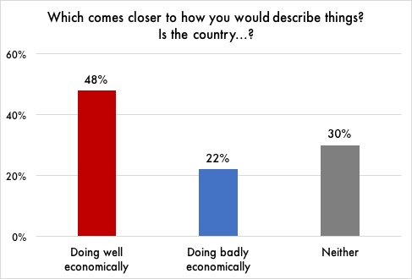

President Trump has frequently touted the economy’s performance under his administration, often tweeting out reports of the stock market hitting new highs. The White House has also balked at suggestions that former President Obama is responsible for the current state of the economy.

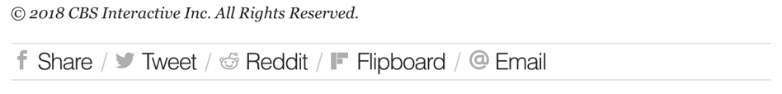

CBS NEWS / February 13, 2018, 7:37 AM

Poll: Nearly Half of Americans Think Economy is Doing Well; Republicans More Optimistic After Trump’s Election



Just less than half of Americans believe the economy is doing well under President Trump, a new poll shows.

A CBS News Poll, released Sunday, found that 48 percent of Americans say the country is doing well economically, compared to 22 percent who say it’s doing poorly. Another 30 percent said it is neither doing well or poorly, according to the poll, which was conducted Feb. 10-12. The poll had 2,164 respondents and has a margin of error of 2.6 percentage points.

Those most positive about the state of the economy tend to be Republicans, researchers said. More than 8 in 10 Republicans say that President Trump is handling the economy well, compared to only 7 percent of Democrats.

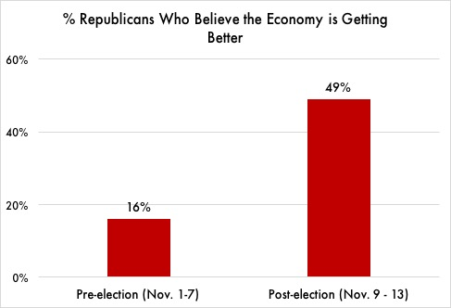“Sustained economic confidence is mostly due to Republicans’ more positive evaluations after Donald Trump won the election,” said the release from CBS News. “Republicans had a dismal view of the economy — especially of its future direction — during President Barack Obama’s two terms.”

The change among Republicans has been swift. Gallup polls conducted just a week before and a week after the 2016 election showed that the proportion of Republicans saying the economy is getting better rose from 16 percent to 49 percent.

*Republicans became more optimistic about the economy after Trump’s election. Source: Gallup Polls, Nov. 1-13, 2017.*

“Republicans are out of their minds if they think the economy is suddenly doing better because of Trump,” said Susan Thomas, a retired schoolteacher from Harrisburg, PA who voted for Hillary Clinton in 2016. “He’s just benefiting from the work Obama did. Anyone who can’t see that is delusional.”

President Trump has frequently touted the economy’s performance under his administration, often tweeting out reports of the stock market hitting new highs. The White House has also balked at suggestions that former President Obama is responsible for the current state of the economy.



CBS NEWS / February 13, 2018, 7:37 AM

Poll: Nearly Half of Americans Think Economy is Doing Well; Democrats More Pessimistic After Trump’s Election



Just less than half of Americans believe the economy is doing well under President Trump, a new poll shows.

A CBS News Poll, released Sunday, found that 48 percent of Americans say the country is doing well economically, compared to 22 percent who say it’s doing poorly. Another 30 percent said it is neither doing well or poorly, according to the poll, which was conducted Feb. 10-12. The poll had 2,164 respondents and has a margin of error of 2.6 percentage points.

Those most negative about the economy tend to be Democrats, researchers said. Only 7 percent of Democrats say President Trump is handling the economy well, compared to more than 8 in 10 Republicans.

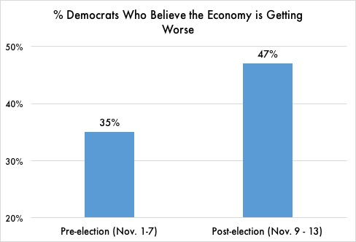“Lagging economic confidence is mostly due to Democrats’ more negative evaluations after Donald Trump won the election,” said the release from CBS News. “Democrats had a more optimistic view of the economy — especially of its future direction — during President Barack Obama’s two terms.”

The change among Democrats has been swift. Gallup polls conducted just a week before and a week after the 2016 election showed that the proportion of Democrats saying the economy is getting worse rose from 35 percent to 47 percent.

*Democrats became more pessimistic about the economy after Trump’s election. Source: Gallup Polls, Nov. 1-13, 2017.*

“Democrats are out of their minds if they think the economy is suddenly doing worse because of Trump,” said Susan Thomas, a retired schoolteacher from Harrisburg, PA who voted for the President in 2016. “He’s rescuing us from all the damage Obama did. Anyone who can’t see that is delusional.”

President Trump has frequently touted the economy’s performance under his administration, often tweeting out reports of the stock market hitting new highs. The White House has also balked at suggestions that former President Obama is responsible for the current state of the economy.

